EXP.NO: 5
DATE:05/03/2025
Write a Servlet to demonstrate the difference between HTTP GET and POST methods by creating a form and handling requests accordingly.

AIM:
To demonstrate the difference between the HTTP GET and POST methods by creating a form in an HTML page and handling the form submissions using two different HTTP methods in a Java Servlet.
ALGORITHM:
1. Input:
- The user fills out a web form with their name and email.
- The form will use both GET and POST methods for data submission.

2. Steps for Creating and Handling the HTTP GET and POST Requests:
- Create an HTML Form:
  - Design an HTML form with two input fields: one for the name and one for the email.
  - Create two buttons to allow the user to submit the form using GET or POST methods.
  - Use the action attribute to define the Servlet URL and specify the form method (either GET or POST).
- Create the Servlet to Handle GET and POST Requests:
  - Write a Java Servlet class that will handle both GET and POST requests.
  - The servlet will have two methods:
    - doGet() to handle the GET requests.
    - doPost() to handle the POST requests.
  - In both methods, retrieve the form data using request.getParameter().
  - In the doGet() method, process and display the data in the URL.
  - In the doPost() method, process and display the data in the HTTP request body.
3. Handle GET Requests in the Servlet:
  - In the doGet() method, use request.getParameter() to retrieve the name and email submitted via GET.
  - Output the data as a response, including the name and email in the URL (visible to the user).
- Handle POST Requests in the Servlet:
  - In the doPost() method, use request.getParameter() to retrieve the name and email submitted via POST.
  - Output the data as a response, displaying the name and email without exposing them in the URL (more secure).
- Return the Output:
  - The Servlet should return an HTML page displaying the name and email entered by the user.
  - For the GET method, the output should be visible in the URL.
  - For the POST method, the output should be visible in the response body, not the URL.
- Deploy and Test the Servlet:
  - Compile the Servlet class and deploy it to a Servlet container (like Apache Tomcat).
  - Test the form using GET and POST methods to see the difference in data submission.
- Observe and Compare GET and POST Results:
  - Test the GET method: The form data is sent in the URL.
  - Test the POST method: The form data is sent in the HTTP request body, not visible in the URL.

Code:
CityServlet.java

package com.example;

import java.io.IOException;
import java.io.PrintWriter;
import javax.servlet.ServletException;
import javax.servlet.annotation.WebServlet;
import javax.servlet.http.HttpServlet;
import javax.servlet.http.HttpServletRequest;
import javax.servlet.http.HttpServletResponse;

@WebServlet("/ClientServlet")
public class ClientServlet extends HttpServlet {
private static final long serialVersionUID = 1L;

protected void processRequest(HttpServletRequest request, HttpServletResponse response, String method)
throws ServletException, IOException {

String name = request.getParameter("name");
String service = request.getParameter("service");
String issue = request.getParameter("issue");

response.setContentType("text/html");
PrintWriter out = response.getWriter();

out.println("<html><head><title>Smart City Response</title>");

out.println("<style>");
out.println("body { font-family: Arial; background: linear-gradient(135deg,#0f2027,#203a43,#2c5364); color:white; display:flex; justify-content:center; align-items:center; height:100vh; }");
out.println(".container { background:#1c2b36; padding:30px; border-radius:12px; box-shadow:0 0 20px #00f7ff; text-align:center; width:400px; }");
out.println("h1 { color:#00f7ff; margin-bottom:20px; }");
out.println("p { font-size:18px; margin:10px 0; }");
out.println("a { display:inline-block; margin-top:20px; text-decoration:none; color:black; background:#00f7ff; padding:10px 20px; border-radius:8px; font-weight:bold; }");
out.println("a:hover { background:#00ff88; }");
out.println("</style>");

out.println("</head><body>");
out.println("<div class='container'>");

out.println("<h1>🌆 Smart City Request</h1>");
out.println("<p><strong>Name:</strong> " + (name != null ? name : "Not Provided") + "</p>");
out.println("<p><strong>Service:</strong> " + (service != null ? service : "Not Provided") + "</p>");
out.println("<p><strong>Issue:</strong> " + (issue != null ? issue : "Not Provided") + "</p>");

out.println("<p>Request submitted via " + method + "</p>");
out.println("<p>Our Smart City team will resolve it soon 🚀</p>");

out.println("<a href='index.html'>Go Back</a>");

out.println("</div></body></html>");
}

protected void doGet(HttpServletRequest request, HttpServletResponse response)
throws ServletException, IOException {
processRequest(request, response, "GET");
}

protected void doPost(HttpServletRequest request, HttpServletResponse response)
throws ServletException, IOException {
processRequest(request, response, "POST");
}
}

bookingform.html

<!DOCTYPE html>
<html>
<head>
<meta charset="UTF-8">
<title>Smart City Portal - GET vs POST</title>

<style>
body {
font-family: Arial;
background: linear-gradient(135deg,#0f2027,#203a43,#2c5364);
color: white;
display: flex;
justify-content: center;
align-items: center;
height: 100vh;
margin: 0;
}

form {
background: #1c2b36;
padding: 30px;
border-radius: 12px;
width: 400px;
box-shadow: 0 0 20px #00f7ff;
}

h1 {
text-align: center;
color: #00f7ff;
margin-bottom: 20px;
}

label {
display: block;
margin-top: 12px;
}

input, select, textarea {
width: 100%;
padding: 10px;
margin-top: 5px;
border-radius: 6px;
border: none;
}

.buttons {
display: flex;
justify-content: space-between;
}

input[type="submit"] {
width: 48%;
margin-top: 15px;
background: #00f7ff;
color: black;
font-weight: bold;
cursor: pointer;
}
input[type="submit"]:hover {
background: #00ff88;
}
</style>
</head>
<body>

<form action="ClientServlet" method="post">

<h1>🌆 Smart City Portal</h1>
<label>Name:</label>
<input type="text" name="name" required>
<label>Select Service:</label>
<select name="service">
<option>Water Supply</option>
<option>Electricity</option>
<option>Waste Management</option>
<option>Road Maintenance</option>
</select>
<label>Describe Issue:</label>
<textarea name="issue" rows="3" required></textarea>
<div class="buttons">
<input type="submit" value="Submit via POST">
<input type="submit" formaction="ClientServlet" formmethod="get" value="Submit via GET">
</div>
</form>
</body>
</html>

OUTPUT:

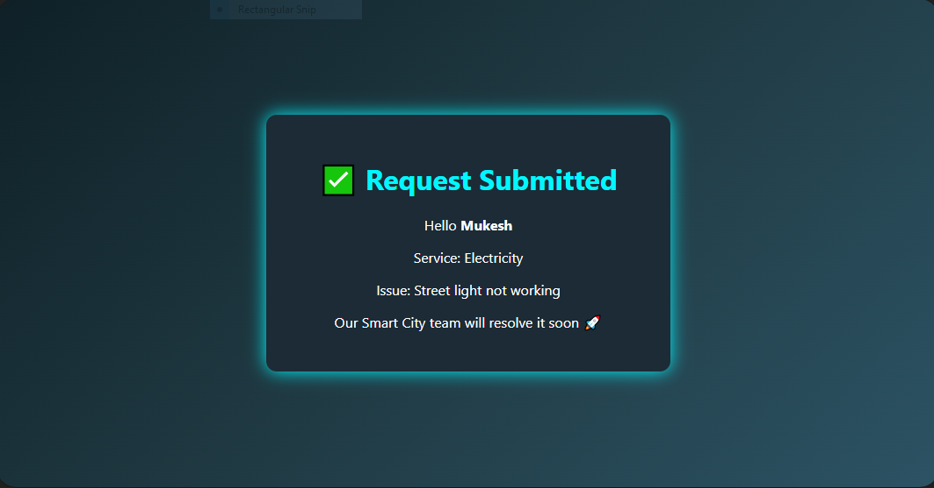
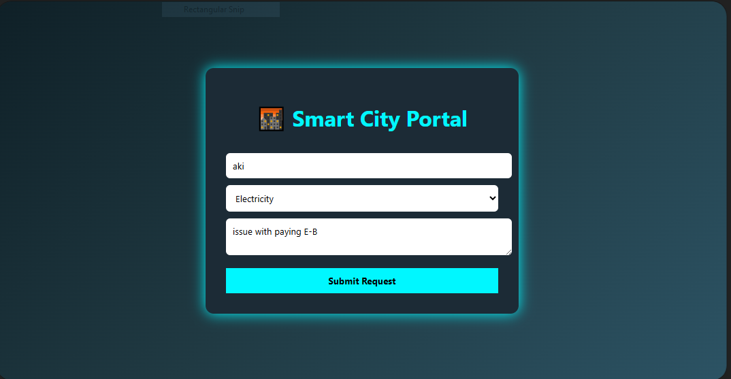

RESULT :
A Servlet is created to demonstrate the difference between HTTP GET and POST methods by creating a form and handling requests accordingly.

